Overview of the interface.

The interface of silent storm is based on the extensive use of the mouse. This way of operating the game is familiar for any player that uses Windows operating system or plays modern games.
Any action can be done with the mouse. And advanced players can use the fully customizable keyboard shortcuts that cover most of the commands a player may need during the game.
The following description covers the most important commands and controls
There are a lot of additional controls. Read the tool-tips for the
The core of the Silent Storm interface is the Unit Panel at the bottom of the game screen. All of the actions a player may need can be accessed via this panel.

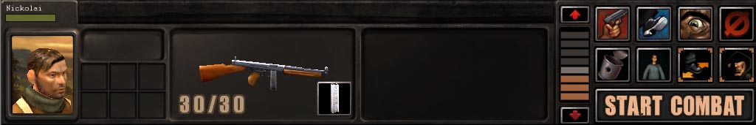

On the left hand-side of the panel there is a portrait of the currently selected character. Next to the portrait of the character there are the indicators of the number of Action Points (APs) and Vitality Points (VPs) – vitality points are shown as a green bar below the character’s portrait.
In the center of the control panel there are two Quick Slots where the player may put the weapons or items that are used most often. One of the Quick Slots is always active and you can for changing the shooting mode and reloading the weapon will also be displayed in the same Quick Slot.
On the right-hand side of the control panel there are the controls for performing actions in combat this part is called Icon Bar. The top row is for attacking , moving and turning and the bottom row is for changing the pose of the character.
Just above the control panel there are two controls that can be used to access the inventory and character screens.
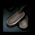 Character Screen icon. (Shortcut - O)
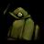 Inventory icon.( Shortcut - I)

Character screen can be accessed on the left-hand side and the inventory can be accessed on the right-hand side of the screen.

At the top of the screen sits the Top Bar that consists of Four buttons – Menu, Journal Mission exit and Mini map (Mini map is inactive in this version) and the Turn Progress Bar.

When you select Menu you’ get to the Escape Menu. If you press Journal – you’ll get to the Clues Journal where you can manage the available clues. If you press the leave button you’ll exit the mission. It is possible if no enemies are around. You can also exit the mission by moving all of the characters to the border and clicking at the void around the combat area.
Selecting Units

Before performing any action with the character you should select this character.

You can left-click on one of the tabs with the characters’ names on it. You can left click on the character figure on the battle field.
Or you can drag the mouse across the figure of one or several characters while holding the left mouse button. In this case the dark rectangle will be displayed with which you can select one or multiple characters. Also you can select one of your characters by pressing the number keys on the main keyboard from 1 to 7
And the last way to select the character is to cycle through all available characters with the “Tab” button.

Combat.

Turns and interrupts

Most of the time playing Silent Storm you will spend guiding your units through combat.
All combats are played in turn based mode.
The game will enter the combat state in one of the following circumstances.
You or the enemies performed an attack with any of the weapons.
Any of your or enemy characters have noticed the character of the other side.

You pressed the “Start Combat” button (ENTER)

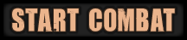

When your characters notice the enemy soldier the icon representing the enemy will appear on the screen.
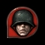 Icon of the enemy that is seen by your currently selected character.
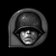 Icon of the enemy that is seen by at least one of your characters but not selected one
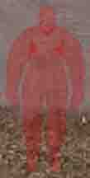 Red ghostly figures represent the last known position of the enemy soldiers.
The turns are displayed on the top bar.
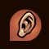 This icon points at the location of the last known position of an unseen enemy.
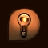 This icon points at the location of the game hints
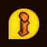 This icon points at the location of the scenario clue

Sometimes the you or your enemies get a chance to interrupt the rivals turn and perform some actions.
In this case the top bar will have “Interrupt” on it.
During the enemy turn the Unit Panel becomes disabled and looks as follows:

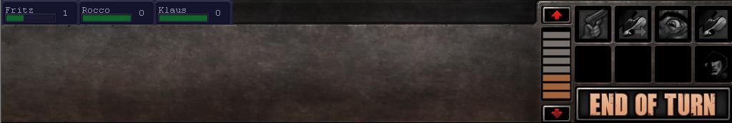

Note the disabled character tabs on top of the panel.

In the combat situation you can use your weapons. To use the weapons they should be in one of the Quick Slots in the center of the control panel and this slot should be active.
The Quick Slots can be activated by clicking on it.
When a weapon is in the active quick slot there is the icon representing attack with this weapon in the top left hand button on the right-hand Icon Bar .

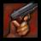 Attack with the current firearm (Shortcut – A)
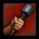 Throwing Grenade(Shortcut – A)
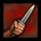 Melee attack with the current melee weapon. (Shortcut – A)
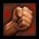 Melee attack with bare hands (requires standing next to the target) (Shortcut – A)
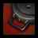 Set a mine (Shortcut – A)
If you press this button you issue the command to attack. Your mouse pointer will change to represent the weapon you use and the additional combat information will be displayed next to it.

Can not attack
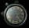 Wait.
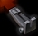 Attack with a gun
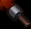 Attack with a grenade
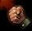Melee attack
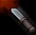Melee attack with a weapon.

The successful hit probability and the AP cost is displayed for the spot the cursor points at.
You can attack the enemies the specific body parts of the enemies and a spot in space. Since the attack is the default action for any enemy the hit probability for the current weapon and the AP cost will be displayed any time you point at the enemy.
To attack the specific location on the enemy’s body you should press the numbers keys on the number keyboard while attacking the enemy. In this case the cursor will change to represent the current hit location.

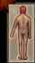– Attack at the head (Shortcut – Num_8+Left Click)
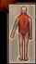 - Attack at the torso (Shortcut – Num_5+Left Click)

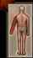 - Attack at the arm (Shortcut – Num_4+Left Click)

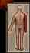 - Attack at the arm (Shortcut – Num_6+Left Click)

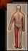 - Attack at the leg (Shortcut – Num_1+Left Click)

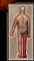 - Attack at the leg (Shortcut – Num_3+Left Click)

There are six firing modes in the game. The firing modes differ both by accuracy and AP cost.
The current firing mode is shown in the bottom left-hand corner of the Icon Bar. You can press this button to get the access to all of the firing modes available for the current weapon. Choose one of them to select the new firing mode.

The firing modes are:
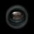 Snipe Shot, (Shortcut T) 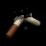 Aimed Shot, (Shortcut W)
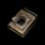 Careful Shot, (Shortcut E) 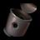 Snap Shot (Shortcut Q)

and two modes for automatic firearms –
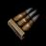 Short Burst (Shortcut F) 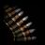 Long Burst. (Shortcut G)
Each firearm can have up to four firing modes.
When you choose the snipe mode and attack the enemy. There will be additional commands appearing in the Icon Bar. They are used to spend more APs on the shot for better aiming. Read tool-tips for more detail.

Moving Units
The characters in Silent Storm can move in a variety of ways. They can walk, run, crawl, sneak, climb over the obstacles and turn around. Fortunately we can control this variety of motions just with a handful of mouse clicks. Movement is the default action for the character.
To select the destination for the character move the cursor to that point and double-click with the left button. If you perform a single click you can view the path that the character will use to reach the destination, so you can change the destination if you don’t like the path.
You can also issue the move command by clicking the Move icon on the Icon Bar
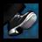 - Move Icon. (Shortcut M)
There are four main movement modes in Silent Storm. Run, Walk, Crouch, Crawl. Each of the modes have it’s own benefits so might want to change the movement mode from time to time. To do this you should click on the respective button in the action panel in the bottom left-hand corner of the screen. The character will change his pose to the selected mode and will move in this mode by default.
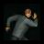 Run (Z) 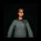Walk (X) 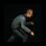Crouch(C ) 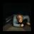 Crawl(V)

Climbing the obstacles is performed automatically. If the path lies across an obstacle or ends on top of it the character will mode next to the obstacle in his current mode and will climb over the obstacle.

When you need your character to move while maintaining the orientation press the
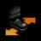 Strafe (D) button in the Icon Bar . It will switch the strafe mode on . You can strafe only while Walking or Crouching.

Character’s actions.

Some times the character needs to look around. To do this press the Look button Icon Bar and then place the cursor anywhere in the direction you want your character to turn and click with the left mouse button. To stop unit press the stop Icon or “ESC”
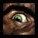 Look icon (L) Look cursor.

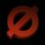 Stop icon (S)

If there are NPCs present on the mission zone the main hero can talk to them. When you point the cursor at such NPC it turns to the talk cursor.

Talk cursor.

Clicking on the NPC will initiate the scripted dialog. The interface will fade and the lower part of the screen will display the dialog.
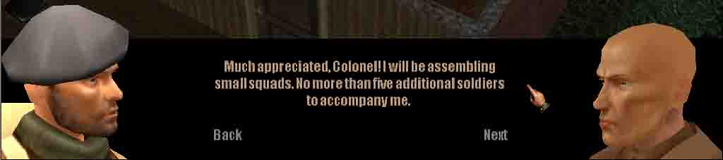

Sometimes the character will need to interact with the different objects on the mission zone. When you point the cursor at the objects that can be used this way, they are highlighted by green outline and the cursor changes to use. Click at the object to interact with it.
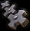 Use cursor. 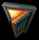 Open door cursor

Camera.

The control of the camera is also relies on the use of the mouse. To move the camera press the right mouse button and drag the mouse around. Moving the mouse horizontally will orbit the mouse. Moving the mouse vertically will adjust the pitch of the camera. Using the mouse wheel will zoom camera in and out.
To scroll the camera you can move the cursor closer to the borders of the Game View. The cursor will change into the arrow and the camera will pan to that direction.
Alternatively you can move the mouse while holding the middle mouse button

If you don’t want to use the mouse to control the camera you can use the key board shortcuts.
You can scroll the view with the arrow keys.
Ctrl+Up/Ctrl+Down – change the pitch.
Ctrl+Left/Ctrl+Right – orbit the camera
PageUp/PageDown – zoom camera in-out
Home – center the camera on the selected character.

Inventory

Apart from the items in the Quick Slots the characters can carry a large number of equipment in their inventory. You can access the inventory by clicking on the icon of backpack in the bottom left-hand corner of the Game View. In the inventory you can rearrange the items. And move them between the inventory and the Quick Slots To move the items click the left-click on it. The item will attach itself to the cursor. The n you can move the item around the backpack and to the Quick Slots. The color of the cursor will be green if you can place the item there and it will change to red if the item can not be dropped in this place.
To drop the item out of back pack you should move it over the game screen and click on the ground. To pick up the item from the terrain you should point the cursor to the item (the cursor will change to the green hand) and click on it. If the item is too small or there is a pile of items you can press “Alt” key. It will bring up the names of the items next to the selected character and you can click on them to put the items into the back pack.

The characters can pick different items from the ground. To do this just point the cursor at any item that can be picked up and the cursor will change to

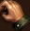 Pick up an item.

Clicking on this item will make the character come to this item and put it into inventory. You can also press ALT button to see the names of all the items the selected character sees. You can then pick up any of these items by pointing and clicking the name of the item.

You can also pick up and carry corpses and unconscious bodies. When your character carries a corpse he can only walk and can not attack. To drop the corpse press the corresponding button on the Icon Bar
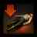 Drop corpse.

The non-weapon equipment is used the same way as the weapons. You place the item you want to use in the Quick Slot activate the Quick Slot and then select the Attack button. But if there is the non weapon item in the Quick Slot the icon will change to represent this item. For example:
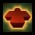 Healing icon.

Then with the changed cursor select the target for the action.

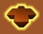 Healing cursor

Shortcut summary.

Camera controls

Keyboard
Arrows move camera
Ctrl-Up/Down – Change camera pitch
Ctrl-Left/Right – Orbit Camera
PageUp/PageDown -

Mouse

Mouse wheel - (zoom in/out)
Move mouse left/right holding RMB Orbit camera
Move mouse up/down holding RMB Change camera pitch.
Move mouse holding RMB +Ctrl – Move camera.
Move mouse holding Middle Button Move camera.

Combat controls

M - Move
S - Stop
A - Attack
L - Look
Z - Run
X - Walk
C - Crouch
V - Crawl
D – Strafe
R - Reload
I - Inventory
O - Character
Q - Snap Shot
W - Aimed Shot
E - Careful Shot
F - Short burst
G - Long Burst
T - Snipe
Tab – Cycle through characters
Home Center camera on selected character
Num_+ Raise one store up.
Num_- Descent one store down.
Alt – Show items next to the character
Large Enter – End of Turn/Start Combat
Num_8 - Attack at the head
Num_5 – Attach at the torso
Num_4 – Attack arm
Num_6 - Attack arm
Num_1 – Attack leg
Num_3 – Attack
1-7 select the respective character.
F5 – Quick Save
F6- Save Game
F7- Load Game
F8 – Quick Load
Сtrl-Q и Ctrl-С – Quit Game.

Pause –Pause Game
` - console
PrintScreen – make screenshot
ScrollLock – Show statistics (fps etc.)

Debug keys

Ctrl+D – Destroy anything that is under cursor
Ctrl+ E – make visible explosion
Ctrl-A - AI map
Ctrl-J – Make explosion
Ctrl-T – Teleport unit
Ctrl-W – Wireframe mode
Ctrl-R – Reload Zone
Ctrl-Y – Switch the shadows mode.
Ctrl-Z – Switch HSR on /off
Ctrl-U – Switch fog mode
Ctrl-K – Switch particles on/off
Ctrl-; - Switch lighting mode
Ctrl-I - Interface on/off
Ctrl-P – Dump RPG info into the console.

